PSU SWENG 500 Team 3 Agile Test Summary Report

8/6/13

Contents

1 Background and Overview 1
2 Test Results 1
3 Variances 3
4 Other Code Related Metrics 3

Background and Overview

This document provides the Test Summary for the testing activities for three iterations of Team 3’s Brewers Buddy project. Brewers Buddy Iterations 1, 2, and 3 Tests were completed on 8/6/2013. During testing, the entire solution was tested. Testing was conducted using various computers containing Microsoft Visual Studio. NUnit Test Adapter was also attached to Visual Studio and assisted the integrated testing process. NUnit is a unit-testing framework for all .Net languages, and is one of many programs in the xUnit family.

Test Results

Test Coverage Overall for Custom Code (Note: We did not do testing on things created already within the framework such as migrations, filters, utilities, etc.)
Name | Not Covered (Blocks) | Not Covered (Blocks %) | Covered (Blocks) | Covered(Blocks %)
BrewersBuddy.Controllers | 1071 | 49.3% | 1098 | 50.7%
BrewersBuddy.Models | 8 | 2.5% | 318 | 97.5%
BrewersBuddy.Services | 56 | 11.7% | 420 | 88.3%
Total | 1135 | 38.2% | 1836 | 61.8%

Tests Run: 317 tests were run and passed.

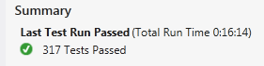

Selected Examples of Passed Tests

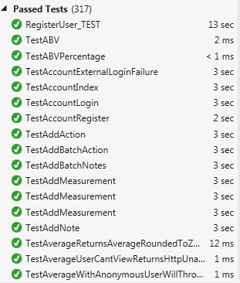

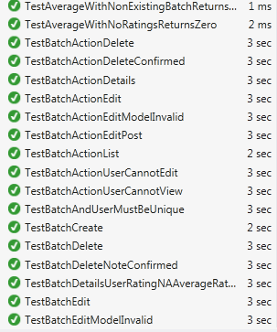

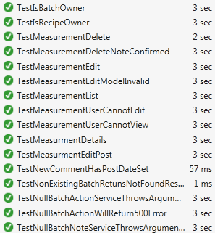

Variances

No testing variances were found 100% of the 317 tests passed

Other Code Related Metrics

Lines of Code: 3073

Maintainability Index: 85

MAX(0,(171 - 5.2 * ln(Halstead Volume) - 0.23 * (Cyclomatic Complexity) - 16.2 * ln(Lines of Code))*100 / 171) According to Microsoft in between 20 – 100 is Green - Overall Green

Depth of Inheritance: All values 4 or under. A value greater than 4 would compromise encapsulation and increase complexity. - Overall Green

Cyclomatic Complexity: All code members are between 1-10, which means the code is structured and well written code and highly testable - Overall Green

